BOOK ORDER & AUTOGRAPH FORM

Child’s Name (please print): ___________________________________________________________________________
Mailing Address: ____________________________________________________________________________________
Special Message to your child from the author (please print): ________________________________________________
__________________________________________________________________________________________________

MICHIGAN HISTORY NIGHTMARES: (free bookmark with every book purchase)
- Volume 1 – Trapped in the Lower Peninsula/A Narrow Escape in the Upper Peninsula
Number of Volume 1 Books ______ x $7.00 each = ______ (tax included)
- Volume 2 – Entombed in a Hopewell Burial Mount/A Shocking Encounter with the
Iroquois and Three Fires Native American Tribes
Number of Volume 2 Books ______ x $8.00 each = ______ (tax included)

- Volume 3 – Michigan Fur Trade…A Hare-Raising Adventure
Number of Volume 3 Books ______ x $9.00 each = ______ (tax included)

- Volume 4 – How Michigan became a State – Lessons from beyond the Grave
Number of Volume 4 Books ______ x $11.00 each = ______ (tax included)

- Volumes 1/2/3/4 – Purchase of Complete Set includes a Free Pen!
Number of Complete Sets ______ x $34.00 each = ______ (tax included)

SPECIALTY ITEMS: that go along with the stories
- Michigan Pens
Number of Michigan Pens ______ x $2.00 each = ______ (tax included) **please choose color
Number of GREEN _____ Number of RED _____ Number of PURPLE _____ Number of BLUE _____

- Tri-Con Dynamics Mood Ring
Number of Mood Rings ______ x $2.00 each = ______ (tax included) **please indicate size
Number Size 5 ___ Number Size 6 ___ Number Size 7 ___ Number Size 8.5 ___ Number Size 9.5 ___

**To find ring size, wrap string around finger, cut string to size, measure length in inches…
Size 5=2-1/4 inches; Size 6=2-1/2 inches; Size 7= 2-3/4 inches; Size 8.5=3 inches; Size 9.5=3-1/8 inches
NOTE: If size is unavailable when order is being filled, next size up will be substituted.

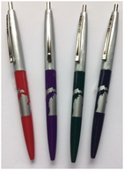
- Glow-in-the-Dark Wolf Bracelet
Number of Wolf Bracelets ______ x $5.00 each = ______ (tax included)

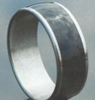
Glow-in-the-Dark
Wolf Bracelet
TOTAL ENCLOSED: ____________
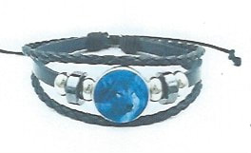
Please make checks payable to: Lynne Smyles
Mail Order To: Lynne Smyles
36576 Capper
Tri-Con Dynamics
Mood Ring
Clinton Township, Michigan 48035

